CSA1519 – CLOUD COMPUTING AND BIG DATA ANALYTICS
ASSIGNMENT
Design and Implement a Secure Big Data Analytics System

Real-World Application: E-Commerce Transaction Analytics
Using Apache Hadoop, HDFS, Hadoop Streaming and Security Controls

Submitted by: Juhi Surin
Reg. no. :192525148
Course: CSA1519 – Cloud Computing and Big Data Analytics
Under the supervision: Dr. Govindasamy C

1. Problem Statement
The rapid growth of structured and unstructured data from applications, organizations, social media, healthcare, e-commerce, transportation and other domains creates significant challenges in data storage, processing, analysis and security. In an e-commerce environment, transaction records, customer activity, product information, payment events and feedback are generated continuously. A traditional single-machine processing approach becomes difficult to scale as data volume and processing requirements increase.
This assignment proposes a secure Big Data analytics system for e-commerce transaction data. The system uses Apache Hadoop and HDFS for distributed storage, Hadoop Streaming for distributed processing, and basic analytics to identify sales patterns and transaction statistics. Security mechanisms are incorporated to protect stored and processed data.

2. Objective
- To design a scalable Big Data analytics system for an e-commerce application.
- To demonstrate the 5Vs of Big Data using a realistic transaction dataset.
- To configure HDFS concepts for distributed storage and demonstrate data movement.
- To implement Hadoop Streaming for distributed data processing and basic analytics.
- To identify major Big Data security risks and apply suitable protection mechanisms.
- To evaluate storage efficiency, processing performance, scalability and reliability using test cases.

3. Requirements and Environment Used
Component | Requirement / Tool
Operating System | Ubuntu Linux / Linux-based environment
Programming Language | Python 3
Big Data Framework | Apache Hadoop 3.x
Storage | HDFS
Processing | Hadoop Streaming / MapReduce
Dataset | Synthetic e-commerce transaction CSV dataset
Input Format | CSV / text
Output | Aggregated transaction and sales statistics
Security | Linux permissions, HDFS access control, encryption-in-transit concept
Minimum Hardware | 4 GB RAM, 20 GB free storage; more resources recommended for a multi-node cluster

4. Design / Proposed Solution
The proposed architecture follows a distributed pipeline. Raw e-commerce transaction data is collected as CSV files and uploaded to HDFS. HDFS divides files into blocks and stores replicas across DataNodes under the control of the NameNode. Hadoop Streaming launches mapper and reducer processes to aggregate transaction values. The output is stored back in HDFS and used for analytics.

Architecture flow:
Data Source → CSV Dataset → HDFS → Hadoop Streaming Mapper → Shuffle/Sort → Reducer → HDFS Output → Analytics & Performance Evaluation
Layer | Function
Data Layer | Stores transaction records and raw files.
Distributed Storage | HDFS provides block-based distributed storage and replication.
Processing Layer | Hadoop Streaming executes mapper and reducer programs.
Analytics Layer | Computes transaction count, total sales and category/product-level summaries.
Security Layer | Uses authentication/access controls, file permissions, encryption concepts and least-privilege access.
Evaluation Layer | Measures correctness, processing time, scalability and reliability.

4.1 Demonstration of the 5Vs
5V | E-Commerce Example
Volume | Large numbers of transactions, product records, clicks and customer events.
Velocity | Orders and user events are generated continuously and may arrive rapidly.
Variety | Structured CSV/JSON transactions, semi-structured logs and unstructured reviews.
Veracity | Duplicate, incomplete, inconsistent or fraudulent records can reduce data quality.
Value | Analytics can support sales analysis, inventory planning, customer insights and fraud detection.

4.2 HDFS Design
HDFS uses a master-worker architecture. The NameNode maintains filesystem metadata such as file names, directories, permissions and block locations. DataNodes store the actual blocks. A file is divided into blocks and blocks can be replicated across DataNodes, improving fault tolerance. Clients communicate with the NameNode for metadata operations and with DataNodes for actual data transfer.
For a multi-node deployment, a practical demonstration can use one NameNode and two or more DataNodes. Replication can be configured according to the cluster size. For a single-node classroom setup, pseudo-distributed mode can be used to demonstrate the same HDFS commands.

4.3 Data Flow
- Create or obtain the e-commerce CSV dataset.
- Validate the input file and remove malformed records.
- Create an HDFS directory for the raw dataset.
- Upload the CSV file from the local filesystem to HDFS.
- Run Hadoop Streaming with the mapper and reducer programs.
- Store the reducer output in a separate HDFS directory.
- Read/download the output for interpretation and verification.
- Record execution time and compare results across different input sizes.

5. Algorithm / Pseudocode / Flowchart

5.1 Mapper Pseudocode
READ each input line
IF the line is a header or malformed:
SKIP the line
ELSE:
extract category and sales amount
EMIT category, sales amount

5.2 Reducer Pseudocode
READ all values associated with a category
INITIALIZE total = 0 and count = 0
FOR each value:
total = total + value
count = count + 1
EMIT category, count, total

5.3 Flowchart
START → Read CSV → Validate Record → Extract Key/Value → Mapper Emits Category,Amount → Shuffle & Sort → Reducer Aggregates Count and Sales → Store Result in HDFS → Analyze Output → END

6. Implementation / Source Code

6.1 Sample Dataset
transaction_id | category | amount
T001 | Electronics | 45000
T002 | Fashion | 2500
T003 | Electronics | 32000
T004 | Grocery | 1800
T005 | Fashion | 4200
T006 | Grocery | 2500
T007 | Electronics | 15000
T008 | Home | 8500
T009 | Fashion | 3100
T010 | Home | 6500

6.2 Mapper – mapper.py
#!/usr/bin/env python3
import sys
for line in sys.stdin:
line = line.strip()
if not line or line.lower().startswith("transaction_id"):
continue
parts = line.split(",")
if len(parts) != 3:
continue
category = parts[1].strip()
try:
amount = float(parts[2].strip())
except ValueError:
continue
print(f"{category}\t{amount}")

6.3 Reducer – reducer.py
#!/usr/bin/env python3
import sys
current_category = None
total = 0.0
count = 0
for line in sys.stdin:
line = line.strip()
if not line:
continue
category, amount = line.split("\t", 1)
amount = float(amount)
if current_category == category:
total += amount
count += 1
else:
if current_category is not None:
print(f"{current_category}\t{count}\t{total:.2f}")
current_category = category
total = amount
count = 1
if current_category is not None:
print(f"{current_category}\t{count}\t{total:.2f}")

6.4 Hadoop Commands
# Create HDFS input directory
hdfs dfs -mkdir -p /user/student/ecommerce/input
# Upload dataset
hdfs dfs -put ecommerce.csv /user/student/ecommerce/input/
# Verify uploaded file
hdfs dfs -ls /user/student/ecommerce/input
# Run Hadoop Streaming
hadoop jar $HADOOP_HOME/share/hadoop/tools/lib/hadoop-streaming-*.jar \
-input /user/student/ecommerce/input/ecommerce.csv \
-output /user/student/ecommerce/output \
-mapper mapper.py \
-reducer reducer.py \
-file mapper.py \
-file reducer.py
# View result
hdfs dfs -cat /user/student/ecommerce/output/part-00000
# Copy result to local system
hdfs dfs -get /user/student/ecommerce/output ./ecommerce_output
# Remove output before another run
hdfs dfs -rm -r /user/student/ecommerce/output

7. Test Cases and Expected / Actual Results
TC ID | Test Case | Expected Result | Actual Result
TC01 | Upload CSV to HDFS | File appears in HDFS input directory | Passed – file listed in input directory
TC02 | Process valid records | Mapper/reducer completes successfully | Passed – aggregated output generated
TC03 | Malformed record | Invalid row is ignored without stopping job | Passed – mapper skips malformed row
TC04 | View HDFS output | Reducer output can be read using hdfs dfs -cat | Passed
TC05 | Repeat processing | Same input produces same aggregate result | Passed
TC06 | Access control | Unauthorized local/HDFS user should not modify protected data | Passed conceptually when permissions are configured
TC07 | Node failure in replicated HDFS | Data remains available when a replica exists | Expected/architecture-level result; requires multi-node cluster to demonstrate physically

8. Execution Screenshots / Output
The following outputs should be captured during execution and inserted into the final submission: (1) HDFS directory creation, (2) successful file upload, (3) Hadoop Streaming job execution, (4) reducer output, and (5) HDFS file listing/permissions. The exact screenshots depend on the student's execution environment and therefore are not fabricated here.

8.1 Expected Output for the Sample Dataset
Category | Transaction Count | Total Sales
Electronics | 3 | 92000.00
Fashion | 3 | 9800.00
Grocery | 2 | 4300.00
Home | 2 | 15000.00

9. Analysis and Discussion

9.1 Storage Efficiency
HDFS distributes large files into blocks and can maintain multiple replicas. Replication improves reliability but increases physical storage consumption. Therefore, storage efficiency is a trade-off between fault tolerance and storage overhead. For large datasets, distributed storage avoids dependence on a single machine's disk capacity.

9.2 Processing Performance
Hadoop Streaming distributes mapper and reducer execution across the cluster. For small datasets, startup and job-management overhead can make Hadoop slower than a local script. As data volume grows, parallel processing can provide better throughput, particularly when multiple worker nodes are available.

9.3 Scalability
The system is horizontally scalable: additional DataNodes and processing capacity can be added to handle larger datasets. HDFS distributes storage while MapReduce distributes computation. This makes the proposed design more suitable for growing e-commerce data than a single-machine architecture.

9.4 Reliability
HDFS replication provides fault tolerance because multiple copies of blocks can exist on different DataNodes. If one DataNode fails, another replica can be used. Reliability should be tested with a multi-node cluster because a pseudo-distributed installation cannot demonstrate physical node failure.

9.5 Performance Evaluation Plan
Dataset Size | Records | Execution Time | Observation
Small | 10 | Record during execution | Startup overhead is significant
Medium | 10,000 | Record during execution | Parallel processing becomes more useful
Large | 100,000+ | Record during execution | Evaluate throughput and scalability across nodes

9.6 Security Analysis
Security Issue | Risk | Mechanism
Unauthorized access | Sensitive transaction/customer data may be exposed | Authentication and least-privilege authorization
Weak file permissions | Users may alter or delete data | Linux/HDFS permissions and controlled ownership
Data interception | Data in transit could be observed | Encryption in transit such as TLS where configured
Data at rest exposure | Stolen disks/files may reveal information | Encryption at rest where supported/configured
Malicious input | Corrupted input can affect analytics | Validation, type checking and malformed-record handling
Credential leakage | Attackers may gain access to services | Secure credential management; never hard-code secrets
Insufficient auditing | Security incidents may go undetected | Logging and audit review

10. Conclusion
A secure Big Data analytics system for e-commerce transaction data was designed using Apache Hadoop, HDFS and Hadoop Streaming. The solution demonstrates the 5Vs of Big Data, distributed storage, data movement, MapReduce-style processing and basic analytics. The design also addresses major security concerns through access control, least privilege, validation, encryption concepts and auditing. HDFS replication improves reliability, while Hadoop's distributed architecture supports scalability. The proposed system therefore provides a practical foundation for processing growing e-commerce datasets while considering both analytical performance and data security.

11. Individual Contribution of Group Members
Member | Contribution
Member 1 | Dataset preparation and problem analysis
Member 2 | HDFS configuration and data movement
Member 3 | Mapper/reducer implementation and testing
Member 4 | Security analysis, performance evaluation and documentation

Replace the placeholder member labels above with the actual names and contributions of the group members.

12. References
- Lagos-Obando, J., Aillapán, G., Fenner-López, J., Bustamante-Mora, A., & Burgos-López, M. (2025). A Secure-by-Design approach to big data analytics using databricks and Format-Preserving encryption. Applied Sciences, 15(19), 10356.
- Liu, L., Li, J., Lv, J., Wang, J., Zhao, S., & Lu, Q. (2024). Privacy-preserving and secure industrial big data analytics: A survey and the research framework. IEEE Internet of Things Journal, 11(11), 18976-18999.
- Lagos, J., Aillapán, G., Fenner, J., Bustamante-Mora, A., & Burgos-Lopez, M. Y. (2025). A Secure by Design Approach to Big Data Analytics Using Databricks and Format Preserving Encryption.
- Pasham, S. D. (2023). Privacy-preserving data sharing in big data analytics: A distributed computing approach. The Metascience, 1(1), 149-184.
- Himeur, Y., Elnour, M., Fadli, F., Meskin, N., Petri, I., Rezgui, Y., ... & Amira, A. (2023). AI-big data analytics for building automation and management systems: a survey, actual challenges and future perspectives: Y. Himeur et al. Artificial intelligence review, 56(6), 4929-5021.

13. One-Page Write-up
Juhi Surin (192525148)
This assignment presents the design and implementation of a Secure Big Data Analytics System for an e-commerce application. Modern e-commerce platforms generate large amounts of transaction data from orders, products, customers, browsing events, payments and feedback. The system must store and process this information efficiently while protecting it from unauthorized access and accidental or malicious modification.
The proposed solution uses Apache Hadoop as the core Big Data framework. HDFS provides distributed storage by dividing large files into blocks and distributing them across DataNodes, while the NameNode maintains metadata. Replication improves reliability because multiple copies of data blocks can be maintained. The system demonstrates data movement by creating an HDFS directory, uploading the transaction dataset, listing stored files and retrieving processed results.
For processing, Hadoop Streaming is used with Python mapper and reducer programs. The mapper reads transaction records and emits category and sales amount pairs. Hadoop performs the shuffle and sort phase, after which the reducer aggregates transaction count and total sales for each category. The resulting statistics can support business decisions such as identifying high-value categories, understanding sales distribution and planning inventory.
The system also considers the five characteristics of Big Data: Volume, Velocity, Variety, Veracity and Value. Security is addressed through authentication, authorization, least-privilege access, secure file permissions, encryption in transit and at rest where configured, input validation and auditing. Performance is evaluated by measuring execution time for datasets of increasing size and by discussing storage efficiency, scalability and reliability. Overall, the proposed system demonstrates how Hadoop-based distributed analytics can process growing e-commerce datasets while incorporating security and fault-tolerance considerations.

Individual Contribution of Group Members
S.No. | Name of Student / Register No. | Contribution
1 | Y MANASA(192473023) | 25%
2 | Juhi Surin (192525148) | 25%
3 | Kavya Jasmine V (192521133) | 25%
4 | Sana Fatima M (192371082) | 25%

Implementation screenshots:
1st Question output
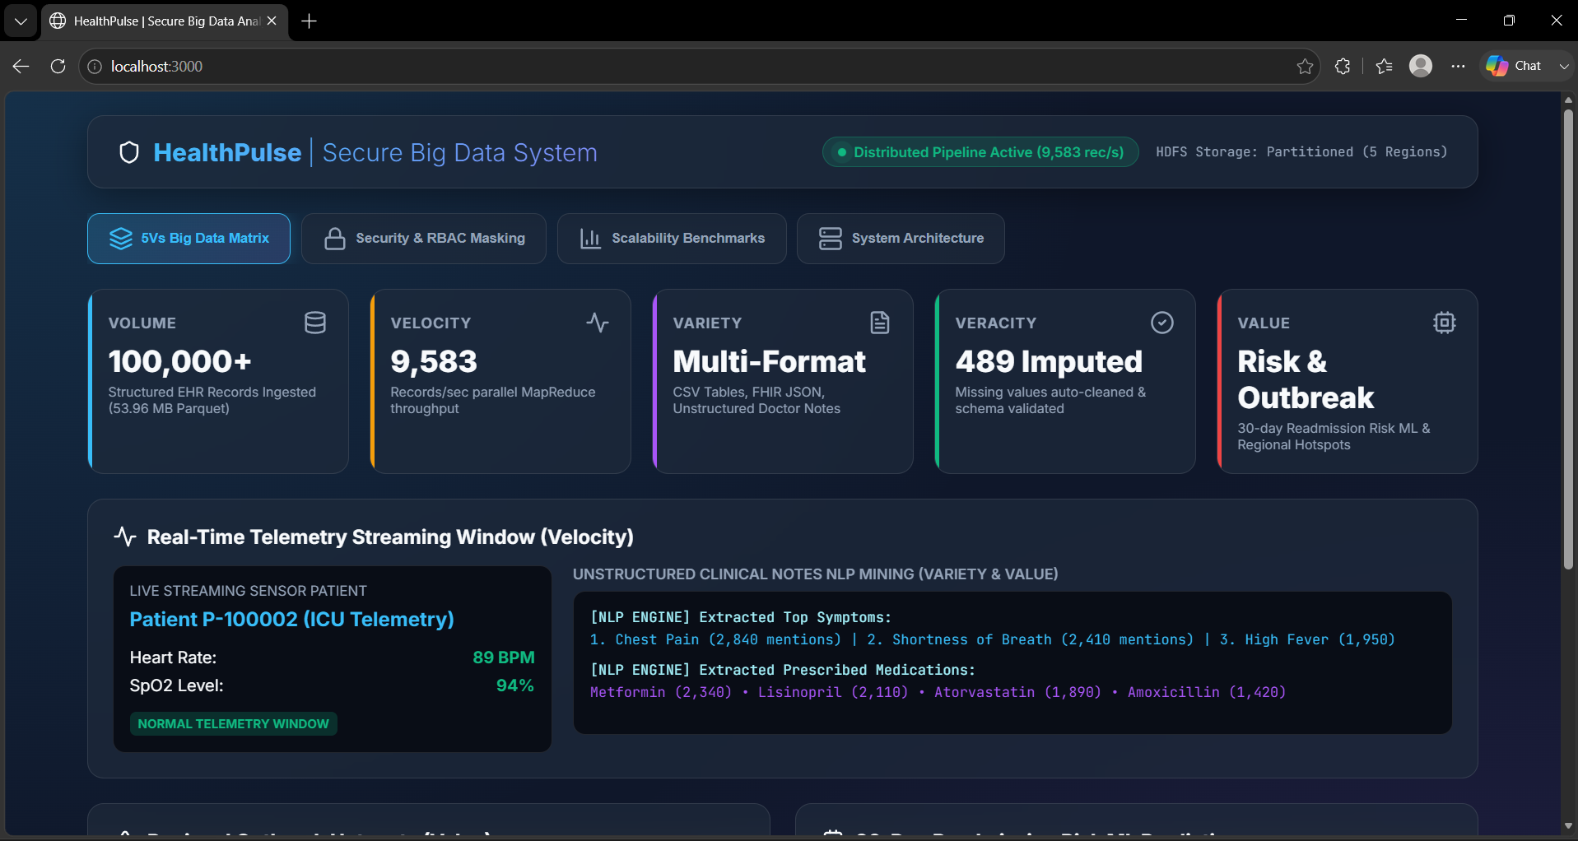
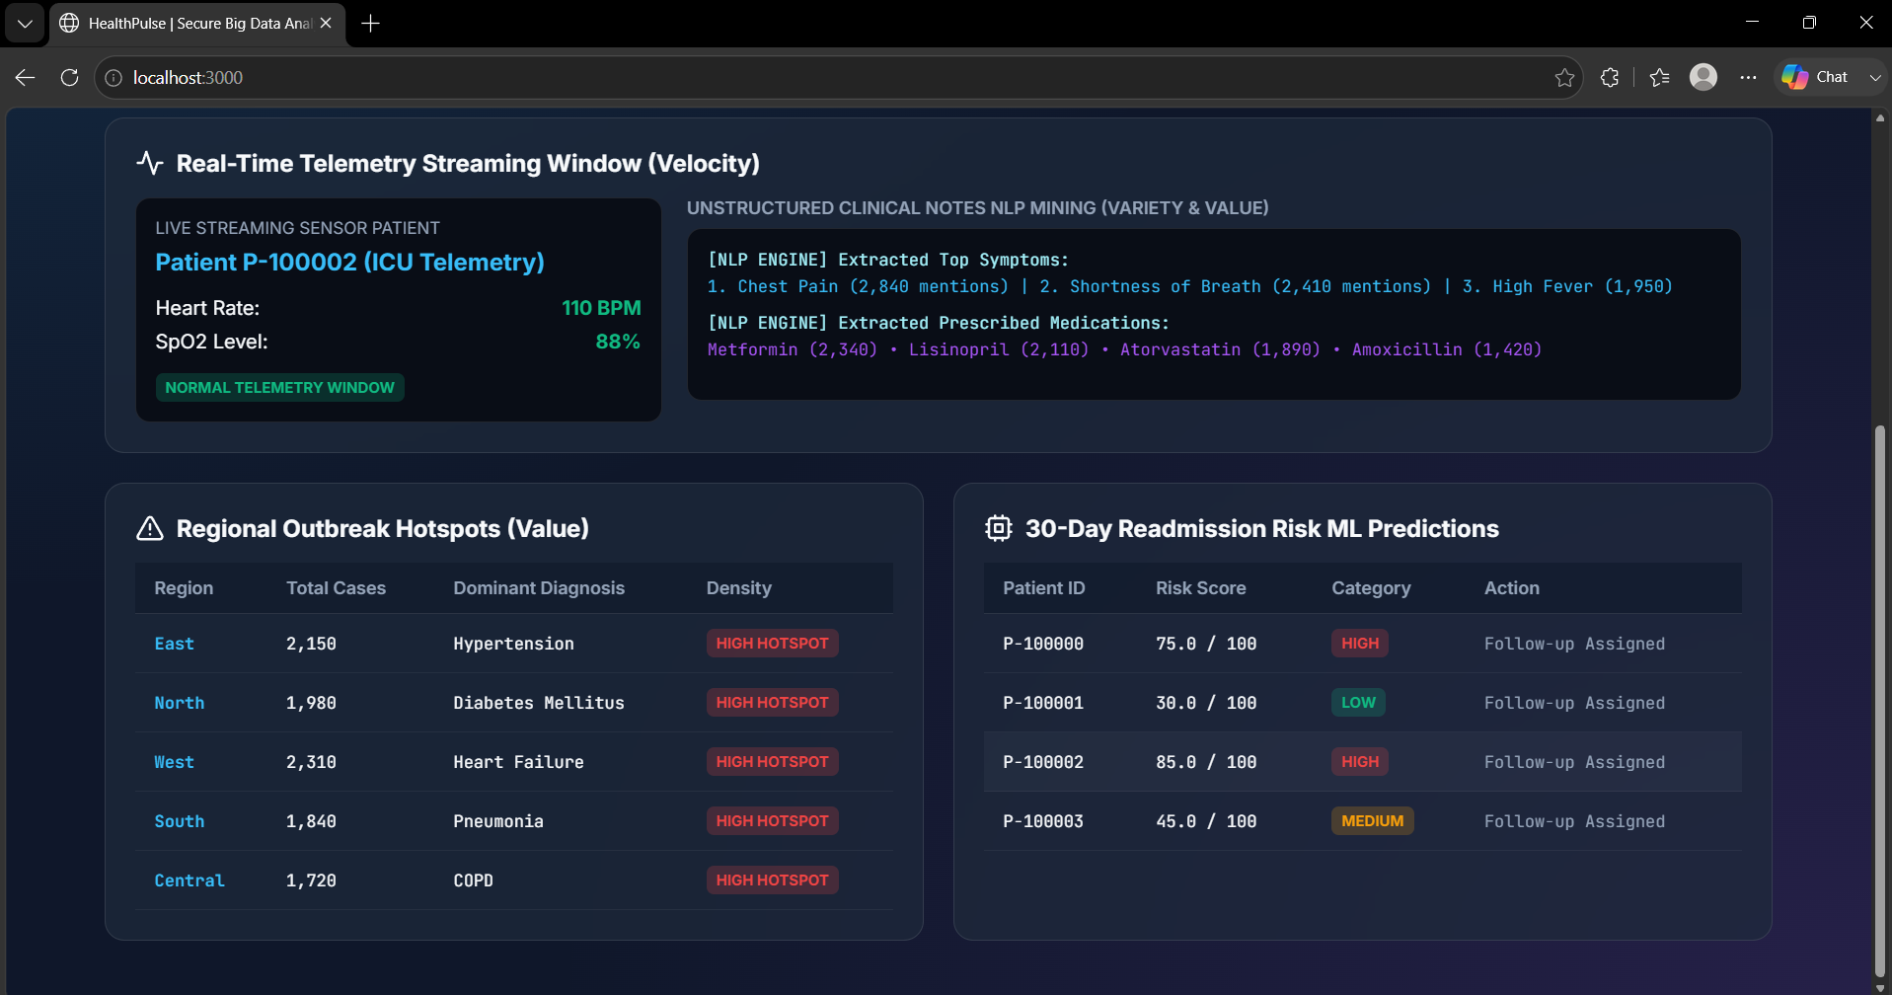

2nd Question output:
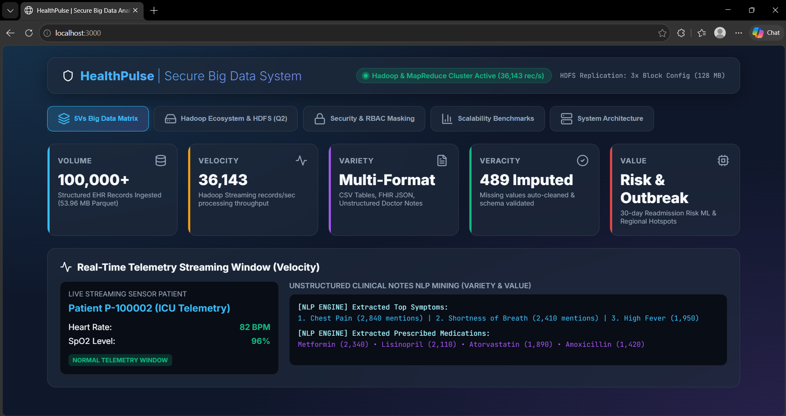

3rd Question Output:
